# BREAKING



Red Sox 10, Braves 8, Final

**Dr. Ebonie Woolcock returns to**

**Dorchester**

**By Bella English** Globe Staff, September 19, 2014, 6:00 p.m.

**6**

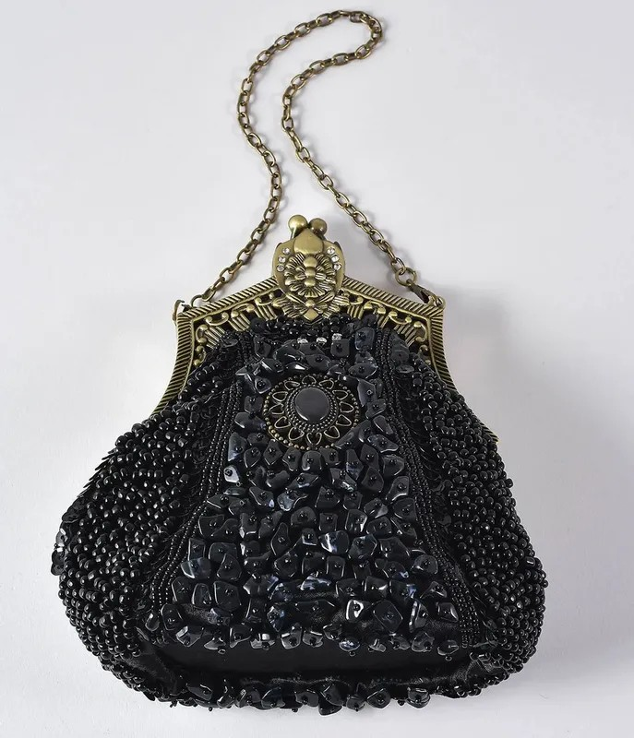

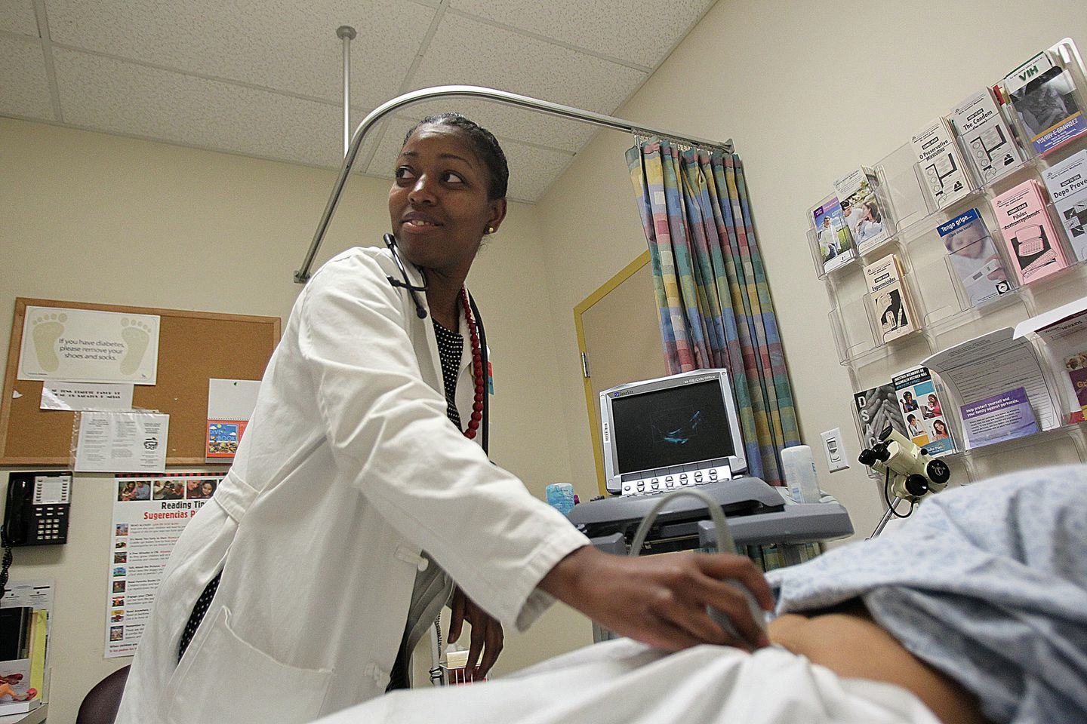Dr. Ebonie Woolcock at Bowdoin Street Health Center in Dorchester, the neighborhood where she grew up. Woolcock, an obstetrician and gynecologist, also has a master’s in public health. SUZANNE KREITER/GLOBE STAFF/GLOBE STAFF



Ebonie Woolcock saw her first cadaver during a summer science program when she was in high school. Far from being repulsed, she was entranced. “I fell in love,” she says.

That teenager is now Dr. Woolcock, an obstetrician and gynecologist who recently returned to her Dorchester roots by joining the medical staff at Bowdoin Street Health Center. The circular path she took from her childhood in Codman Square back to the old neighborhood was one pitted with setbacks, but one that also taught her the value of perseverance — and role models.

It wasn’t until college that Woolcock first set eyes on an African-American doctor. “I had never seen a black doctor in real life,” she says. “The only one I knew was Bill Cosby on TV. For me, there was always this need to be visible to that brown boy, that brown girl, to show them that they could be a doctor too.”



Ebonie Woolcock with her little sisters Yorkela (left) and Lejae (right). WOOLCOCK FAMILY

# BOSTON GLOBE VIDEO

Advertisement



2:23

Baker announces ‘VaxM SHARE

Indeed, minority students are sorely underrepresented in medical schools, according to Tour for Diversity in Medicine, a nonprofit that travels to traditionally black colleges to encourage students to consider going to medical or dental school. According to cofounder Alden Landry, an emergency room doctor at Beth Israel Deaconess Medical Center, blacks, Hispanics, and Native Americans make up 30 percent of the US population, but only 6 percent of practicing physicians.

Governor Charlie Baker announced residents who are fully vaccinated against COVID-19 will have the chance to win $1 million in a special Lottery sweepstakes. (Photo by Matt Stone/Boston Herald via AP)

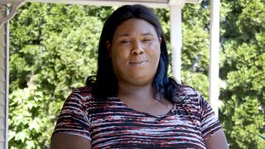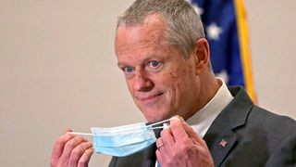

**Baker Moose What announce spotted Black ‘VaxMillio on liberation lottery Route 3 means program in to me:**

**Chelmsfo Athena**

**Vaughn**

**NOW PLAYING**

Get The Big To-Do in your inbox

**s ns’**

**rd**

Your guide to staying entertained, from live shows and outdoor fun to the newest in museums, movies, TV, books, dining, and more.

Enter Email

[example@email.com](mailto:example@email.com)

**Sign Up**

His group wants to increase those numbers. “Studies show that minority providers are more likely to practice in underserved areas and to treat patients on Medicaid and Medicare,” Landry says. “And patients are more likely to respond to providers who have the same racial or ethnic background as they do. Patient satisfaction is higher, compliance with medications and plans of care are higher.”

Dr. Myechia Minter-Jordan, an internist who is president and CEO of the Dimock Center in Roxbury, says that has been her experience. Patients have said “that I speak to them in a way they understand, that they’re comfortable asking me questions,’’ she says. “Patients trust me because I look like them.”

Advertisement

Landry’s group plants the seed in students’ minds, and provides mentoring and support. “Everyone assumes physicians are geniuses and everything has been smooth sailing for them,’’ he says. “The reality is, we had pitfalls, detours, and wrong turns, but we still got to where we wanted to be.”

**MOST POPULAR ON BOSTONGLOBE.COM**

1. Baker announces ‘VaxMillions’ lottery program, offering $1 million cash prizes to boost vaccination rates
2. Message in a bottle, tossed into the sea in Rhode Island, found in Azores
3. Life sciences is poised to be Boston’s dominant industry. Has the area become the Silicon Valley of biotech?
4. The downside of ditching masks: the return of colds, flu
5. The case for prosecuting Donald Trump
6. How white supremacy weaponizes ignorance
7. A treasure map for an American tyrant
8. ‘Boo Boo’ the South Shore Bear captured on video roaming in Duxbury
9. Paul Pierce to launch ‘Truth’ marijuana brand in Massachusetts
10. 5 things to know about the VaxMillions lottery sweepstakes in Mass.

And that can be particularly true with physicians like Woolcock who overcame economic hardship and family tragedy. She was the daughter of a teenage mother who worked as an administrative assistant for the MBTA. Her father owned a small auto-mechanic shop.

Woolcock’s mom was also the daughter of a teen mother, and she did not want that path for her daughters. The way out of the cycle, she believed, was education. There were no rewards for A’s on a report card; those were expected.

Woolcock and her sisters participated in Metco, a state program in which inner-city children attend suburban schools. Its aim is to increase diversity in suburban schools while giving city students more opportunities.

Woolcock attended Framingham schools from first grade through high school graduation, while her sisters went to Weston.

“I think oftentimes, growing up in the inner city, you become what you see around you, if you’re not exposed to another way of life,” says Woolcock, 31. “In Framingham, being exposed to people who were more well off, people who owned homes, who had certain skills, helped me.”

Woolcock was 19 when her mother, a nonsmoker, died of lung cancer at 38. Her sisters were 15 and 12. Their father had been deported to his native Jamaica a year earlier for reasons Woolcock says she’s unclear about. He died in 2008.

The sisters at Ebonie’s 2010 graduation from medical school; Lejae at right, Yorkela left.

WOOLCOCK FAMILY

Advertisement

That first year, the girls’ grandmother moved from Virginia to take care of them. After a Boston winter, she returned south.

That’s when Woolcock became “Sister Mom,” as she calls it. After her mother was diagnosed, she had applied to the Early Medical School Selection Program at Boston University. The program works with 10 historically black colleges, including Hampton University in Virginia, where Woolcock was a freshman, and accepts them into both undergraduate and medical school.



**VIEWS FROM OUR COLUMNISTS**

**YVONNE ABRAHAM**

Energy efficiency is a low- hanging fruit to combat climate change. So why can’t everyone get access to it?

**KEVIN CULLEN**

Bill Bratton on American policing and the challenge facing the Boston Police Department

**THOMAS FARRAGHER**

A salute across the ages to an old squad leader

**SHIRLEY LEUNG**

A working mother’s manifesto: Pandemic provides a once-in-a- generation chance to course correct how we work

**JENEÉ OSTERHELDT**

Juneteenth and the meaning of Black liberation in Boston

**ADRIAN WALKER**

‘The best Boston movie no one’s ever seen’: ‘Blue Hill Avenue’ at 20

“I needed to be home to take care of my sisters,” says Woolcock, who took a year off from college. “We all kind of raised each other.” Her sisters went on to college too. One is an accountant in Hollywood, the other a teacher in Washington, D.C.

“Ebonie definitely sacrificed a lot,” says her sister Lejae, 24, the schoolteacher. “After our parents died, the family was talking about splitting us up, and Ebonie knew my mother’s wish was to always have us together. I am getting my master’s and want to get my PhD and have all these big dreams because of someone like Ebonie. She’s my role model.”

Woolcock graduated from Boston University School of Medicine in 2010, finished her residency in June, and was hired at Bowdoin Street, affiliated with Beth Israel Deaconess, where she delivers babies. “My first one as a grown-up doctor was Aug. 21,” she says, beaming. She also has a master’s degree in public health with a focus on community health and teen pregnancy.

Advertisement

On a recent day, she sees a list of patients at the center, starting with a checkup on a woman who delivered a boy two weeks earlier. The patient speaks Cape Verdean-Creole, and there’s an interpreter in the examining room.

Woolcock asks the patient about her mood, and the woman responds that the baby is fine, but she misses her teenage son, whose father put him “in a program for 45 days.” Now the boy won’t return home.

There are tears, and Woolcock offers sympathy and a Kleenex box and suggests a future visit with the staff social worker. The advice seems to help.

The Center seems a perfect fit for her. She is one of three black doctors — the other two are Cape Verdean — out of 18 on staff. “I love my job,” she says. “I had always wanted to go back to the inner city. I get to be visible to people in my neighborhood.”

The community has embraced her. “I just want you to know I’m very proud to see you,” is a typical comment, she says. Woolcock has also gotten e-mails from other black doctors in the hospital welcoming her.

Dr. Minter-Jordan can relate. When she trained and worked at Johns Hopkins in

Baltimore, the black staff expressed pride in her. “Cafeteria workers, cleaning people, nurses, techs, people on every single level, would see me walking through the hallways and tell me how proud they were to see me. Here, patients tell me the same. To have that community support is so encouraging, to have people recognize you because you’re one of the few.”

Advertisement

Minter-Jordan knows that she — and Woolcock — could make more money in other settings. But both agree that giving back to the community that supported them is invaluable. “The jobs we are most successful at speak to us in a way that’s beyond dollars,” she says.

In fact, when Dr. Celeste Royce interviewed Woolcock for the Bowdoin Street job, it was her interest in the neighborhood that set her apart. “She was so incredibly enthusiastic about coming back to Dorchester,” says Royce, who is the clinic’s ob-gyn director.

The patients there are diverse, with five languages routinely spoken, through interpreters. “Ebonie saw this as an inspiring challenge rather than an insurmountable challenge,” Royce says. “Not everyone gets that, but Ebonie does.”

One of Woolcock’s goals involves trying to help teens avoid unwanted pregnancies. “Children are a blessing and should not be used as an excuse not to achieve goals.”

Woolcock continues to seek her own mentors. After her residency, she started a two-year fellowship at the Kraft Center for Community Health. Every month, she and nine other fellows meet at the center downtown and get help formulating their goals.

Her plan is to establish a “centering pregnancy” model at Bowdoin Street. “It’s a new model of care that’s proven to have better results for pregnancy,” she says. Instead of obstetrics being one-on-one care, it would offer group care for issues such as weight and blood pressure. “It builds a community of women we don’t often have in the inner city.”

She’d like to add financial literacy and life skills to the mix: “If you start including that in prenatal care, maybe the next pregnancy will be planned, not unplanned.”

Through the Kraft program, she now has an adviser, a physician at Brigham and Women’s Hospital whom she checks in with regularly about her plans.

Does she plan to have children herself? “I hope so,” Woolcock says. “But I think after losing my parents and raising my sisters, I need some ‘me’ time now.”

Bella English can be reached at english@ globe.com.

**Show comments**

**MORE ON GLOBE.COM**

**SPONSORED BY: PHILIP MORRIS INTERNATIONAL**

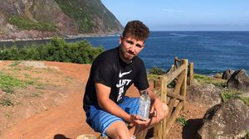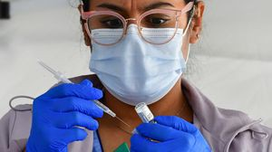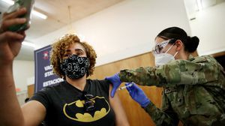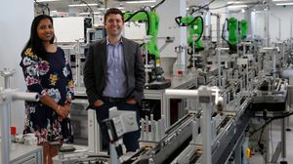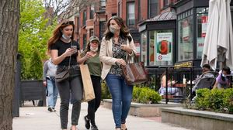

**After the pandemic, health care will never be the same**

From preparing for the next pandemic to rethinking clinical trial requirements, health care practices are quickly evolving.

**A treasure map for an American tyrant**

Donald Trump exposed weaknesses that a would-be dictator could exploit to end our democracy. It’s now up to lawmakers, voters, and public officials to prevent that from happening.

**RI NEWS**

**Message in a bottle, tossed into the sea in Rhode Island, found in Azores**

The note was written in 2018 by a 13- year-old who was visiting family in Rhode Island.

**OPINION**

**I got the Johnson & Johnson vaccine. The pause makes me believe in it more.**

The worst thing that could happen now is for the recommendation by the FDA and CDC to pause the vaccine’s administration to spur a new wave of vaccine hesitancy.

**5 things to know about the VaxMillions lottery sweepstakes in Mass.**

Here are five things you should know about the VaxMillions program, which will make some lucky winners living proof that trusting the science really does pay.

**INNOVATION ECONOMY**

**Life sciences is poised to be Boston’s dominant industry. Has the area become the Silicon Valley of biotech?**

Since December, you can find six major indications that Boston is the undisputed center of the life sciences industry, a place where ideas and products that change ― and save ― people’s lives around the world originate.

**‘Boo Boo’ the South Shore Bear captured on video roaming in Duxbury**

Duxbury police said on Twitter that a resident living on Elm Street spotted Boo Boo in the backyard around 8:30

a.m. Tuesday, eating birdseed.

**Death penalty should be reinstated for Tsarnaev in Boston Marathon bombings case, Biden administration tells Supreme Court**

The Biden administration is asking the Supreme Court to reinstate the death penalty against Dzhokhar Tsarnaev for the Boston Marathon terror bombings.

**America's blind spot: Thousands of drivers shouldn't be licensed** A Boston Globe investigation of how bureaucratic negligence has left lethal drivers on the road.

**The downside of ditching masks: the return of colds, flu** Since the state’s mask mandate was lifted, face coverings have started to come off — and stay off. But according to infectious diseases doctors, the return of facial freedom might come with some downsides, like a resurgence in cases of the common cold and the flu.

**METRO SPORTS BUSINESS & TECH OPINION**

WELCOME, JOHN

**TODAY'S PAPER**

**Check out this week's virtual events**

RSVP now

**LAWMAKERS STRIKE DEAL TO RESTORE PANDEMIC-ERA POLICIES, INCLUDING EVICTION PROTECTIONS, TO-GO COCKTAILS**

**MOST READ IN THIS SECTION**

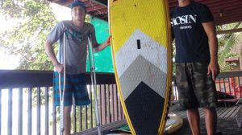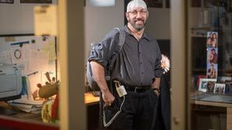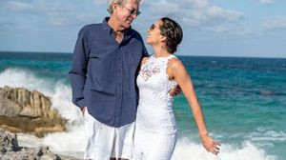

**HEALTH ANSWERS**

**Is it normal to get blurred vision when exercising?**

**ADDRESS**

**Gardeners seem to dig Rose of Sharon again**

**CHRISTOPHER MUTHER**

**A cabin on a lake for**

**$50 a night, or a posh inn at $250 a night? Scoping out the best way to experience Vermont**

**Colin Cook lost his leg — and nearly his life — in a 2015 shark attack. But his journey was just beginning**

**BACK TO NATURE**

**Professional guides reveal the best fly-fishing spots in New England**

**Recipe for Suzanne Lombardi’s molasses-clove cookies**

**Scalp device might help patients with brain tumors**

**Looking back on 50 years: A Q & A with Rachael Ray**

**NAMES**

**David Southworth and Desiree Zabriskie get hitched**

**FOLLOW US**

**SUBSCRIBE NOW MY ACCOUNT CONTACT MORE**



Digital Access Home Delivery Gift Subscriptions

Log In

Manage My Account Customer Service

Help & FAQs Globe Newsroom Advertise

Newsletters / View The EPaper /

Order Back Issues / News In Education / Search The Archives / Privacy Policy / Terms Of Service / Terms Of Purchase / Work At Boston Globe Media /

Do Not Sell My Personal Information

©2021 Boston Globe Media Partners, LLC